Hampshire County Councillor Update, March 2025 – Calleva Division

Dear All

Apologies for the lateness of this month’s report. Devolution and Local Government Reorganisation have been all consuming topics recently.

Highways Information

Reporting Highway Problems . The more that is reported, the quicker things get done.

Links to report road issues are here:

Potholes: https://www.hants.gov.uk/transport/highways/report-a-problem/potholes

Tree/hedge problems: https://www.hants.gov.uk/transport/highways/report-a-problem/treehedge

Flooding/drainage issues: https://www.hants.gov.uk/transport/highways/report-a-problem/flooding

Pavement problems: https://www.hants.gov.uk/transport/highways/report-a-problem/paving

Broken or missing signs: https://www.hants.gov.uk/transport/highways/report-a-problem/brokensigns

Faulty street lights: https://www.hants.gov.uk/transport/highways/report-a-problem/streetlight

Faded or missing road markings: https://www.hants.gov.uk/transport/highways/report-a-problem/road-markings

Problems with rights of way: https://www.hants.gov.uk/landplanningandenvironment/rightsofway/reportaproblem

When reporting an issue, you’ll be sent an email confirming a reference number for the report. If you would like me to follow this up for you then do please forward that message to me and I will chase for you.

Hampshire County Council's Budget

This graphic below shows you how each £1 of your Council Tax will be spent next financial year in Hampshire. When you include schools spending then social care, school transport and education make up almost 87% of our budget.

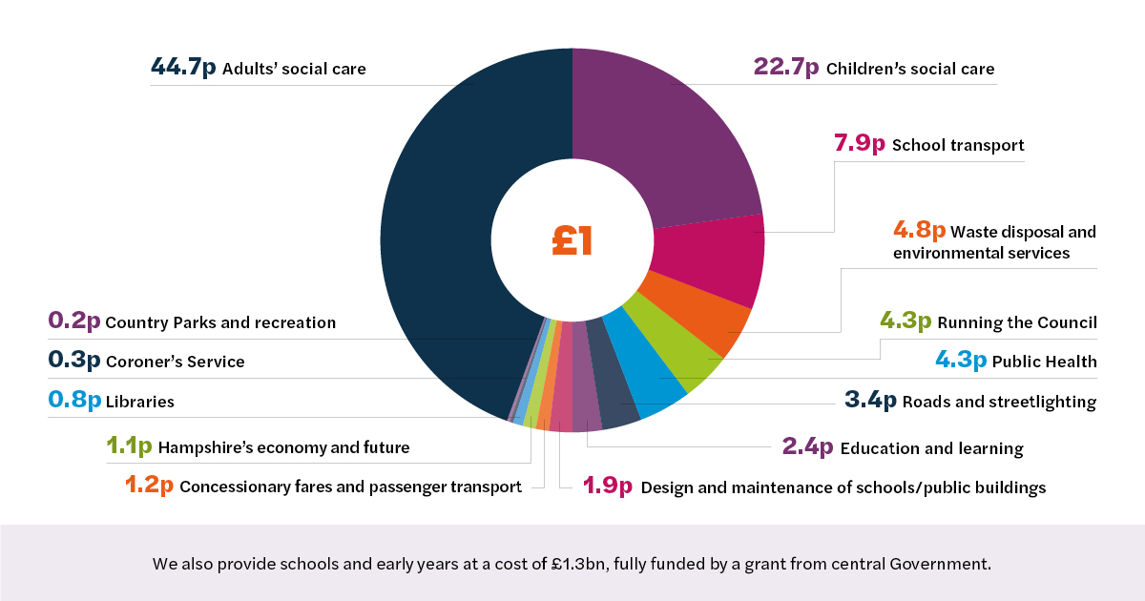

At our budget setting meeting Hampshire's Full Council
agreed our budget for the year ahead which sees an increase of 4.99% in Council Tax. We had asked the government to increase it by a larger amount and they refused our request.

Why did we ask for a larger rise?

None of us want to increase Council Tax. But, the County Council's services are underfunded, and the reason for that in large part is our historically low Council Tax rate, which is why we needed to request an above 5% increase from Government.

Hampshire's Council Tax this financial year is £1533.24 for a band D property - the second lowest in the country. In Surrey the equivalent rate is £1,758.60, West Sussex £1,714.95, and Oxfordshire £1,820.56 for example.

Each 1% of Council Tax increase in Hampshire nets an additional £8million in revenue for the Council. So, a 5% increase results in £40 million in additional revenue this year.
Offset that against the ever rising cost of social care. Every month in Hampshire we see a net increase of 30 people living in care homes who become reliant upon the County Council to pay their costs - even at the most basic level of care these 360 people add a further £18.7 million of cost to our budget each year.

Every month we are seeing an additional 200 applications for Education Health and Care Plans - the first step for children to register for SEN support. That exponential rise is the reason our budget for Home to School transport (for which SEN children qualify for free) has increased from £24 million per year at the end of the pandemic to £105 million next year.

Add to this the effect of employers National Insurance, which will cost us £10.5 million this year - we will get a one off reimbursement of £8 million from Government with nothing for future years.

Consider inflation or pay rises - these of course add further to the bill. We have cut over £700million from our budgets in the last 10 years, and will continue to look for further savings, but frankly there is little left to find and our reserves will, by 2026/27, be exhausted. This is the context within which we find ourselves and the background to both well founded concerns around services and council tax.

For months now, we have tried to engage with this government about our financial situation and have asked for meetings to discuss a positive way forward in partnership. In all that time we have been ignored despite huge pressures on our budget from adult social care and special education costs.

The County Council does not want to raise council tax above the 5% limit. We want to be given the tools to become more entrepreneurial, be given powers to decide where to spend and raise money free of Whitehall diktat. Perhaps our residents will not be surprised - given the present economic management of the country - all these suggestions were ignored too.

We were left with no choice but to agree to give the government our reasons to increase Council Tax above the referendum limit because it is all they asked us to do after finally replying to our letters calling for a meeting.

However, the government has said it will take money from shire counties like ours and give to councils in the midlands and north - some of them bankrupt. It has burdened us with increased costs via employer national insurance and living wage increases we will not get back. The situation is now much worse.

Hampshire County Council is well run. It has the second lowest council tax nationally. As you can see, we sought the increase only due to the rising costs of social care, special educational needs and those increased costs and lack of funding from the government. We have used our reserves to balance the budget so far but this is not sustainable and by the end of the next financial year they will be gone.

So, we present a budget which will include proposals for more savings and an undertaking that while we look for more ways to reduce our costs we will also be promising to continue to spend our budget wisely, protecting our most vulnerable residents, fixing the roads as best we can and looking after our children who are at risk of harm.

Stubbington Outdoor Centre and proposed Secure Children’s Home

There is much misinformation circulating about the proposals for a new Secure Children's Home at Stubbington.

Once a consultation has commenced there is a process through which we must go to reach a decision. So, let me be very clear:

- NO decision has been taken.
- The consultation responses have NOT been ignored.
- Both the forthcoming Select Committee and Cabinet meetings will be held in public and will be broadcast on the HCC Youtube channel.
- There are confidential appendices to the report which include commercially sensitive information, and we will only need to go into a private session of either the Select Committee or Cabinet if anyone wishes to interrogate the information contained within these. Frankly, there is no need to do this as they are in large part not material to the eventual decision.

We are working very hard to find a solution to the challenge we face over balancing the need for a Secure Children’s Home (taking into account the constraints the Department for Education are placing on us in attempting to do so) vs the desire to maintain a study centre at Stubbington.

Struggling to keep your home warm in Hampshire? 
The Hitting the Cold Spots service, funded by Hampshire County Council, is here to help! 

Get FREE support from experienced advisers at the Environment Centre (tEC), an independent charity. They can assist with:

Resolving energy billing issues
Saving money & energy at home

Advice line open Mon-Fri, 9am-5pm Call: 0800 804 8601 Email: staywarm@environmentcentre.com

Find more info & advice at Hitting the Cold Spots – the Environment Centre (tEC) and the council’s website, including energy efficiency tips and grant details: https://hantscoldspots.environmentcentre.com

My County Councillor’s Grant

For 2024/25 I have given financial support to the following Parishes;-

Sherborne St John – Entrance protection Chute Pavilion
Hartley Wespall – Church organ restoration
Sherfield on Loddon – Christmas Reindeer Trail
Mortimer West End – Car park entrance protection gate
Silchester Group – Equipment for Roman Wall clearance
Sherfield on Loddon – Sleepers for Allotment Association
Silchester Village Hall -Refurbishment funding
Hartley Wespall – Speed gun
Hannington – Notice Boards & Bench
Pamber – Entrance Gate barrier

Cllr Rhydian Vaughan MBE
Fb.com/tellrhydian

