Hampshire County Councillor Update 53- Calleva Division – November 2025

.

Highways Information

MAJOR M27 CLOSURE – PLAN AHEAD THIS CHRISTMAS & NEW YEAR
If you’re travelling over the festive period, please take note of the dates for the closure of the motorway between Southampton and Portsmouth:
The **M27 will be fully closed in both directions between Junctions 9 (Whiteley) and 11 (Fareham)** from **8pm on 24 December 2025 until 4am on Sunday 4 January 2026**.
This closure is essential to install a brand-new four-lane underpass using an innovative engineering technique that avoids months of disruption later. But it does mean **serious delays are expected** if you don’t plan ahead.
**What you need to know:**
- Full closure J9–J11 in both directions.
- Diversion via the A27 (expect heavy traffic, especially 10am–4pm daily).
- Exit available: westbound at J11 (Fareham/Gosport) and eastbound at J9 (Whiteley/Park Gate).
- No westbound entry at J11 (towards Southampton/A32) and no eastbound entry at J9 (towards Portsmouth).
If arranging Christmas and New Year travel please plan your journeys in advance:
Travel outside peak hours
Use alternative routes
Ask yourself if the journey is essential
I know this will cause significant inconvenience, and we thank local communities and road users for their patience while this vital work is carried out. This short closure for the innovative work will save months of additional disruption, lane closures and congestion.
 For updates and full details, visit the official Christmas closure webpage:
https://www.hants.gov.uk/transport/M27-junction-10/christmas-closure?utm_source=SAPHybris&utm_medium=email&utm_campaign=5342&utm_term=M27%20J10%20-%20Motorway%20Closure%20Update___Link&utm_content=EN

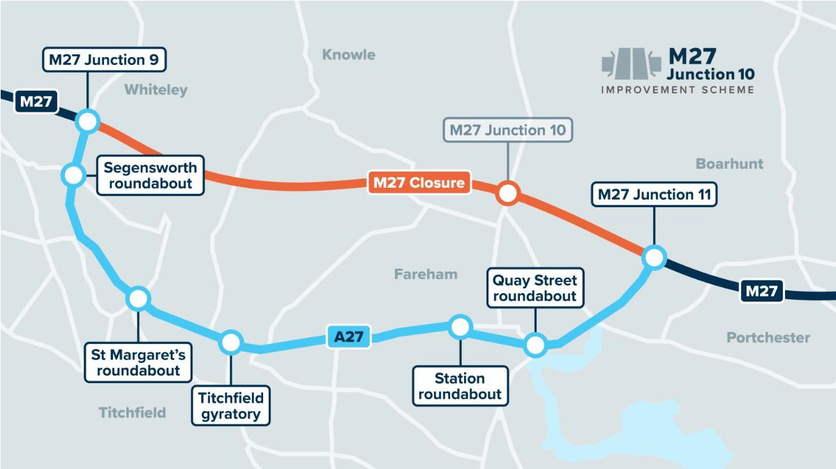

Reporting Highway Problems

Links to report road issues are here:

Potholes: https://www.hants.gov.uk/transport/highways/report-a-problem/potholes

Tree/hedge problems: https://www.hants.gov.uk/transport/highways/report-aproblem/treehedge

Flooding/drainage issues: https://www.hants.gov.uk/transport/highways/report-aproblem/flooding

Pavement problems: https://www.hants.gov.uk/transport/highways/report-a-problem/paving

Broken or missing signs: https://www.hants.gov.uk/transport/highways/report-aproblem/brokensigns

Faulty street lights: https://www.hants.gov.uk/transport/highways/report-aproblem/streetlight

Faded or missing road markings: https://www.hants.gov.uk/transport/highways/report-aproblem/road-markings

Problems with rights of way: https://www.hants.gov.uk/landplanningandenvironment/rightsofway/reportaproblem

When reporting an issue, you’ll be sent an email confirming a reference number for the report. If you would like me to follow this up for you then do please forward that message to me and I will chase for you.

Parish Council Bus Shelter Grant Scheme

Hampshire County Council has launched a new grant scheme to help Parish Councils replace or refurbish bus shelters – making them more attractive, visible, and welcoming for passengers.
Funded through the Department for Transport’s Bus Service Improvement Plan (BSIP) 2025/26 Bus Grant, this scheme is all about improving local infrastructure and encouraging more people to use public transport.

Who can apply? Parish Councils that own and maintain existing bus shelters.
How much is available? Up to £15,000 per shelter site – for either refurbishment or installation of a new shelter at an existing site.
When to apply? Applications are open now and must be submitted by 28 February 2026. Awards will be made on a rolling basis from early 2026.

Parish Councils will need to provide quotes from commercial suppliers as part of their application.
For more details, including the application form and guidance, visit Hampshire County Council’s website or contact the Passenger Transport Team at: passenger.transport.enquiries@hants.gov.uk

This is a great opportunity to improve local facilities and make bus travel more appealing for residents.

Southern Water hosepipe ban lifted from 31st October 

Southern Water has confirmed that the hosepipe ban is lifted from31st October 2025. Thank you to everyone who played their part in conserving water over the summer months—it really made a difference in protecting our precious chalk streams and keeping supplies flowing.

While restrictions are no longer in place, I’d encourage us all to keep up good water-saving habits where we can. Every drop saved helps build resilience for the future.

2026 County Council Elections
The Times has reported that leaders of the Devolution Priority Programme areas are calling for a further postponement of County Council elections, currently scheduled for May next year.
You can read the article here: https://www.thetimes.com/.../0a601557-49fe-4c0a-b9de...
To be absolutely clear: we have not requested any delay to elections, nor have we had conversations with Government about one.
When we spoke to a Times journalist, we made it clear that Hampshire is not part of any discussion about postponement. we am only aware of the idea through colleagues elsewhere. It is therefore disappointing that the article suggests that we have asked for further postponement.
Our position is straightforward: we have not, and will not, ask for an election postponement.
Ultimately, this is a decision for the Government. Last year’s delay was to enable devolution, which is now substantially complete. It was the Labour Government that subsequently imposed Local Government Reorganisation.
This is their project, their timeline, and their decision as to whether they can deliver what they want with or without elections.

County Councillor Grants
The County Councillor Grant scheme is operating once more, with a lesser amount of £5,000 and new criteria as follows:
Hampshire County Councillor Grants – Updated Criteria (September 2025)

Following a comprehensive review, Hampshire County Council has revised its County Councillor Grants Scheme to reflect budget constraints and improve effectiveness. Key changes include:

- Reduced Allocation: Each County Councillor now has an annual grant budget of £5,000, down from £8,000.

- Eligibility Restrictions:
  - Grants are only available to organisations, not individuals.
  - Organisations cannot apply for the same project in consecutive years.
  - Applications must demonstrate community benefit, especially if from religious or statutory bodies.

- Funding Limits:
  - A maximum of £1,000 per project is now in place.
  - Grants for seasonal or time-specific events must be awarded before the event date.

- Transparency and Branding:
  - All funded projects must acknowledge County Council support in promotional materials.

- Application Assessment:
  - Previous grant awards (from the last two years) will be considered during evaluation.
  - Preference may be given to organisations without access to other funding sources.

These changes aim to ensure the scheme remains fair, transparent, and aligned with the Council’s strategic priorities while managing financial pressures.

General Updates from HCC:

Hampshire County Council honours new Aldermen

Two former Hampshire County Councillors have been recognised today with the award of the title of Honorary Alderman, for their distinguished service to the people of Hampshire
Hampshire County Council honours new Aldermen | Hampshire County Council

Consultations to be requested on School and Post-16 Transport Policies

Parents could soon be asked for their views on Hampshire County Council’s School Transport and Post-16 Transport Policies
Consultations to be requested on School and Post-16 Transport Policies | Hampshire County Council

Remember, Remember – stay safe this Bonfire Night

With Bonfire Night just around the corner, Hampshire County Council’s Trading Standards team has issued seasonal safety tips to help everyone to ‘play it safe’ and enjoy the festivities responsibly
Remember, Remember – stay safe this Bonfire Night | Hampshire County Council

Hampshire County Council backs residents to quit smoking this Stoptober – free support available

Quitting smoking isn’t easy, but you don’t have to do it alone. Hampshire County Council is encouraging residents to take part in Stoptober, the national campaign that helps thousands of people each year start living smokefree
Hampshire County Council backs residents to quit smoking this Stoptober – free support available | Hampshire County Council

Hampshire County Council’s Children’s Services recognised in national awards

One of Hampshire County Council’s Children’s Services teams has been recognised as ‘Team of the Year’ at the national Social Worker of the Year Awards
Hampshire County Council’s Children’s Services recognised in national awards | Hampshire County Council

A warm welcome for all – upgrades to Basingstoke Discovery Centre to support residents this winter

Basingstoke residents will soon enjoy an even warmer welcome at their local library thanks to refurbishment works taking place at Basingstoke Discovery Centre next month
A warm welcome for all – upgrades to Basingstoke Discovery Centre to support residents this winter | Hampshire County Council

Hampshire County Council continues to grow SEND provision with more specialist places and inclusive support

Hampshire County Council is continuing its long-term investment in special educational needs and disabilities (SEND) provision, with plans well underway to deliver 1,000 additional specialist school places between 2025 and 2030.This includes a mix of new places in both dedicated special schools and Resourced Provisions (RPs), which are specialist environments based within mainstream schools
Hampshire County Council continues to grow SEND provision with more specialist places and inclusive support | Hampshire County Council

Foster Care – a stepping stone on the journey back home

Could you be part of a child’s journey back home to their family?
Foster care – a stepping-stone on the journey back home | Hampshire County Council

Cllr Rhydian Vaughan MBE

