Hampshire County Councillor Update 51 – Calleva Division

Dear All

Here’s the monthly report for October. Local Government Reorganisation submissions are finally settled, and devolution discussions are progressing well, so now the focus turns back to more usual and much more productive matters.

Here’s the latest update.

Highways Information

Reporting Highway Problems

Links to report road issues are here:

Potholes: https://www.hants.gov.uk/transport/highways/report-a-problem/potholes

Tree/hedge problems: https://www.hants.gov.uk/transport/highways/report-aproblem/treehedge

Flooding/drainage issues: https://www.hants.gov.uk/transport/highways/report-aproblem/flooding

Pavement problems: https://www.hants.gov.uk/transport/highways/report-a-problem/paving

Broken or missing signs: https://www.hants.gov.uk/transport/highways/report-aproblem/brokensigns

Faulty street lights: https://www.hants.gov.uk/transport/highways/report-aproblem/streetlight

Faded or missing road markings: https://www.hants.gov.uk/transport/highways/report-aproblem/road-markings

Problems with rights of way: https://www.hants.gov.uk/landplanningandenvironment/rightsofway/reportaproblem

When reporting an issue, you’ll be sent an email confirming a reference number for the report. If you would like me to follow this up for you then do please forward that message to me and I will chase for you.

£850 MILLION risk to taxpayers – why Hampshire must be cautious on reorganisation
The BBC’s report last week revealed the Government has done no new analysis of the costs of local government reorganisation — relying instead on a 2020 PwC study.
PwC’s updated figures show:
- The wrong model could cost £850m over 5 years and deliver no long-term savings.
- Smaller unitary councils (populations ~300,000) risk piling up unsustainable costs.
As said before — in Hampshire County Council statements and to the press — these changes aren’t just about lines on a map. They affect complex, life-changing services like adult social care, which Hampshire already delivers to 1.4 million people every day. Fragmenting them risks higher costs, reduced resilience, and disruption for residents.
Yes, reform at the right scale can work. But rushed, poorly-designed reorganisation could leave Hampshire taxpayers paying more for less — and frontline services under greater strain.
We must demand evidence-based decisions, rigorous scrutiny, and a clear plan that protects both services and value for money.
You can read the BBC report here: https://www.bbc.co.uk/news/articles/cj9wxnlnrxdo

Plan Submitted
Hampshire County Council’s Cabinet have now approved our submission to Government for Local Government Reorganisation across Hampshire and the Isle of Wight.

We have put forward what we believe is the strongest option—one that gives the new authorities the best chance of financial resilience, safeguards and enhances the services people rely on, and offers residents confidence that, wherever they live—countryside or city, village or town—they will be able to understand, engage with, and influence their council.

At the heart of our proposal are the people we support. To you, we give this assurance: while we remain in place, your care and wellbeing will continue to be our priority.

To our staff, whose dedication and professionalism underpin everything we do: we see your hard work, we value the service you provide, and we will stand with you through the uncertainty and disruption ahead.

To the people of Hampshire, we commit to managing this process with competence and professionalism—never forgetting that it is your money we spend, and you whom we serve.

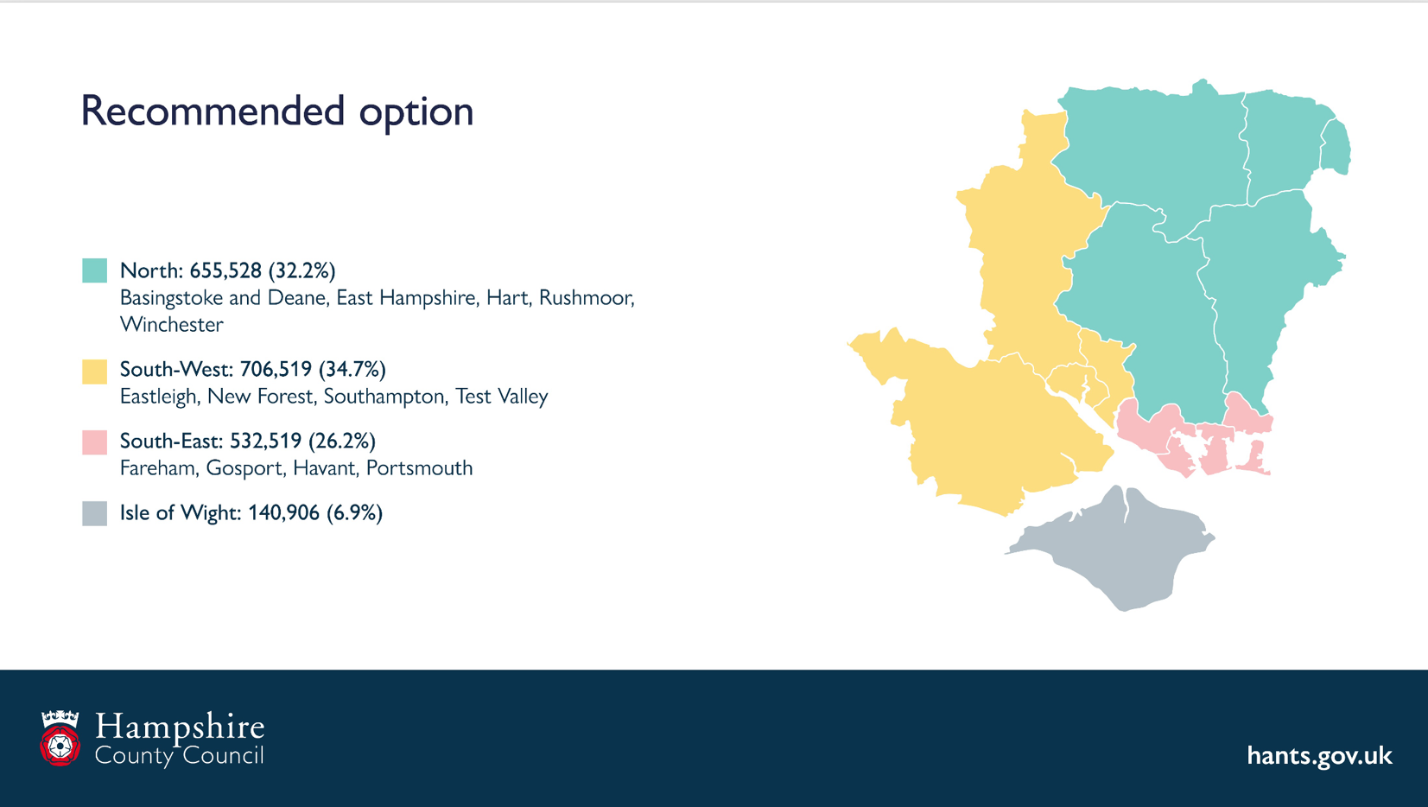
And to the fellow leaders: our task is complete. This should no longer be a source of division. Now is the time to move forward together—with competence, professionalism, and kindness. Because this is not about us. It is about the staff for whom we are responsible, the residents we represent, and above all those who depend most on the services we provide.

Flags

Flags around our area have sparked a range of reactions—some proud, some concerned. We’ve heard from many of you about the Union Flags and Flags of St George flying locally.

we understand these symbols mean different things to different people. In times of celebration, they often go unnoticed. But today, they’re drawing attention—and questions.

So here’s our approach as far as HCC is concerned:

If a flag is dangerous or obstructive—covering road signs or blocking junction views—we’ll remove it.

If it’s safe and not causing issues, it stays.

This isn’t about politics—it’s about practicality. Our highways teams are focused on potholes, drainage, and vegetation. That’s where their time is best spent rather than removing flags.

If you’ve put up a flag, please keep an eye on it. Autumn weather can be rough, and no one wants tatty flags flapping from lampposts. A garden flagpole might be a better option—and yes, there are sensible rules around that.

Thinking of installing one?
No planning permission needed if it’s under ~4.5m and flying a recognised flag.
You’ll need permission for taller poles or promotional flags.
When in doubt, check with the planning team.

Let’s keep our community safe, respectful, and tidy..

Help Shape Hampshire’s Climate and Weather Resilience Inquiry
Hampshire’s coast is one of our greatest treasures—and one of our most vulnerable assets. With rising sea levels, more intense storms and an ever-changing shoreline, coastal erosion and landslips threaten our homes, heritage and local economy.
Parliament's Environment Food and Rural Affairs Committee has launched a call for evidence on Climate and Weather Resilience, and they want to hear from people who live, work and care for our coastline.
What they’d love you to tell them by 10 October:
- The scale and nature of risks from coastal erosion and landslips in your community
- Existing strategies or gaps in research and policy (including the FCERM Strategy)
- Social, economic and psychological impacts on affected families and businesses
- How well current support (financial compensation, relocation help, wellbeing services) meets local needs
- Whether emergency services and local authorities have the resources and training to respond, especially in remote or rural coastal spots
- The threats to landscapes, heritage sites and public access—and how to safeguard them
Hampshire County Council is already stepping up to the challenge.
Our highways teams are:
- Installing sustainable drainage systems to reduce flood risk on key routes
- Reinforcing vulnerable road corridors against extreme weather events
- Integrating climate resilience into every new road and bridge project
Meanwhile, our countryside projects are:
- Restoring wetlands and natural floodplains to absorb storm surges
- Strengthening shingle ridges and saltmarshes that buffer wave energy
- Replanting native vegetation to stabilise cliffs and slopes
Your lived experience and local expertise can help shape stronger, fairer policies—and make sure Hampshire leads the way in climate resilience. Submit your written evidence to the EFRA Committee by 10 October:
https://committees.parliament.uk/call-for-evidence/3748/
Please share this post with neighbours, community groups and organisations that have a stake in protecting Hampshire’s coastline. Let’s make our voices heard!
Adult Social Care Funding in Hampshire

Hampshire County Council is under huge financial pressure, and one of the reasons is that the NHS, through the local Integrated Care Board (ICB), is not contributing enough funding to cover the rising costs of adult social care.

What this means is that the Council is being forced to pick up the bill for services that are really the NHS’s responsibility – like hospital discharge support, reablement after illness, and specialist mental health placements for younger adults. These are not statutory duties for the Council, but without them, hospitals would struggle even more.

The result? Millions of pounds are being diverted from other vital services, leaving the Council’s budget stretched to breaking point. Unless the NHS fully funds the health-related care it is responsible for, Hampshire residents will face cuts elsewhere.

Put simply: the Council is paying for NHS services out of local budgets, and that’s not sustainable.

At our Cabinet meeting this week we warned that this situation cannot sustain. We are out of step with other Councils in southern England, who receive much greater support to deliver these services.

Hampshire County Council statement on the death of Her Royal Highness The Duchess of Kent

Hampshire County Council is deeply saddened by the news of the death of Her Royal Highness The Duchess of Kent

Hampshire County Council statement on the death of Her Royal Highness The Duchess of Kent | Hampshire County Council

Parents with children due to start secondary school next year can now apply for their child’s school place

Don’t get spooked by the deadline – apply for your child’s secondary school place by 31 October | Hampshire County Council

Help to support residents facing barriers to employment

Hampshire County Council has unveiled plans to help more residents across the county into meaningful, sustainable work, especially those who have faced barriers such as long-term health conditions, caring responsibilities, or lack of qualifications

Help to support residents facing barriers to employment | Hampshire County Council

£100,000 funding boost to help more people make a splash

Swimming is set to become more accessible across Hampshire, thanks to a £100,000 funding boost approved today by Hampshire County Council

£100,000 funding boost to help more people make a splash | Hampshire County Council

Cllr Rhydian Vaughan MBE
Calleva Division
Fb.com/tellrhydian

