Hampshire County Councillor Update – Calleva Division

From the Leader of Hampshire County Council, Cllr Nick Adams-King

Dear Everyone

Time for my monthly update for December. It doesn’t seem possible the year is almost over. I’d like to take this opportunity to wish you and your loved ones a very Merry Christmas and a Happy New Year.

Here’s my latest HCC County Councillor update:

Highways Information

Clearing up after the recent storms

Huge thanks are due to the Hampshire highways teams who responded to over 50 emergencies over the last month when Storm Bert hit the county.

The heavy rain and strong winds brought down trees and caused some roads to flood.

There may be some disruption to the road repair schedules this week as a consequence of emergency work for teams over the weekend.

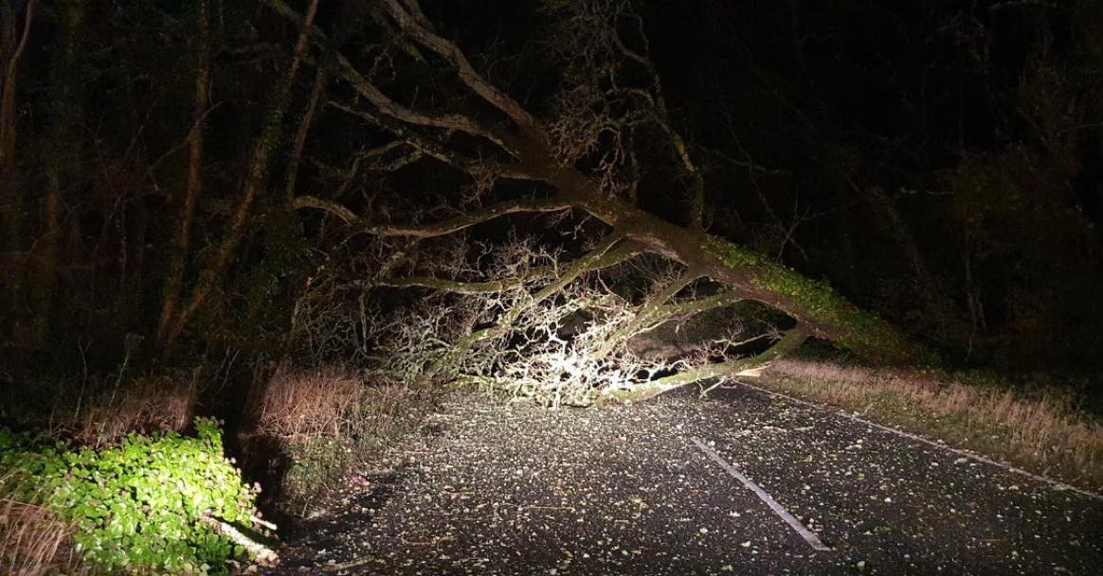

Gritter Names

There have been a few gritter reports as the cold weather has arrived. I was asked a couple of times if I could share the names given to each of Hampshire's gritters.

Not all are named, new ones sometimes are awaiting the competitions held by schools to name them, but the current batch are shown in the graphic below.

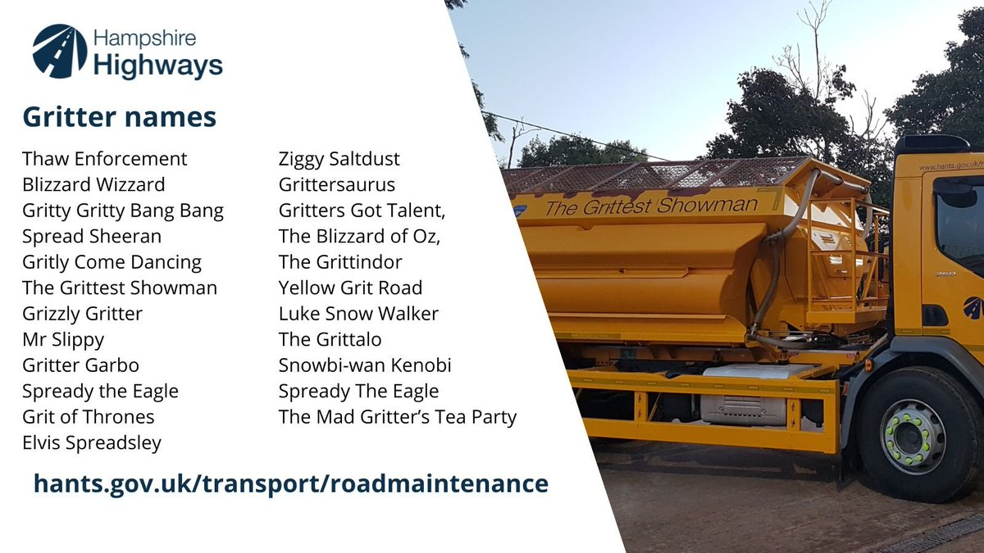

Hampshire Highways - ready for winter

With winter here, HCC's Highways teams are geared up to keep you moving through all weather conditions and ready to work 24/7 to deal with emergency incidents including fallen trees, flooded roads, and icy surfaces.

Earlier this year, we accelerated our work to strengthen roads via our two-year additional investment programme that has ploughed an extra £22.5 million into repairs. As a result, we’ve put more resources into fixing road defects including potholes – and carried out almost 181,000 repairs in the 12 months to April this year, and over 80,000 repairs completed during April to September.

Salt Bins

HCC's network of blue and yellow community salt bins have been refilled ready for the coming months, making salt freely available for anyone to spread on local roads and pavements – useful to ‘join up’ with the salting on main roads by our gritters.

A little salt goes a long way, you’ll only need one tablespoon to treat up to a square metre of road or pavement.

If you’re able to, salting your local roads when it’s forecast to be icy can be a big help for your community, reducing the risk of incident and injury, especially for those who are less mobile.
You can report salt bins needing re-filling, those that are damaged or request one for your area here: https://www.hants.gov.uk/transport/highways/report-a-problem

Reporting Highway Problems

Links to report road issues are here:

Potholes:https://www.hants.gov.uk/transport/roadmaintenance/roadproblems/potholes

Tree/hedge problems:
https://www.hants.gov.uk/transport/roadmaintenance/roadproblems/treehedge

Flooding/drainage issues:
https://www.hants.gov.uk/transport/roadmaintenance/roadproblems/flooding

Pavement problems:
https://www.hants.gov.uk/transport/roadmaintenance/roadproblems/paving

Problems with rights of way:

https://www.hants.gov.uk/landplanningandenvironment/rightsofway/reportaproblem

When reporting an issue, you’ll be sent an email confirming a reference number for the report. If you would like me to follow this up for you then do please forward that message to me and I will chase for you

Support for Hampshire’s Farmers

I and Hampshire County Council’s entire Cabinet met with farmers on Thursday 28th Nov. who had come to protest about the Labour government’s Inheritance Tax changes that will land farming families with huge bills they cannot afford.

My Conservative colleagues David Drew and Edward Heron tabled a motion in support of Hampshire farmers at a meeting of the full council in Winchester.

Beforehand they joined the cabinet outside to meet with farmers, their families and NFU representatives to discuss the changes announced last month by the Chancellor Rachel Reeves.
She imposed a 20% inheritance tax on farms worth more than £1m from 2026-2027 through changes to Agricultural Property Relief. Farms were previously free of the tax.

The move could affect 2500 farms a year, according to the Central Association of Agricultural Valuers, and not the 500 the government initially claimed.

Many families will be unable to meet the bill and be forced to sell up, ruining a way of life across the county and putting food security at risk, the county’s Conservatives explained.

I made this comment at the meeting “This tax really goes to show how much Labour doesn’t know or care about farming and our countryside communities here in Hampshire.

“Putting farming families, who have worked the land in Hampshire for centuries in some cases, under so much pressure when they are already struggling is completely wrong and will have consequences for our food security and our rural economy when farmers give up.

“Sadly, Labour – an urban party – thinks farmers are all rich when many are only asset rich but cash poor and rely on the ability to pass their land on tax free to remain viable family farms.

“The government needs to rethink this financially and morally illiterate policy and give our Hampshire farmers their livelihoods and futures back.”

I'm grateful to my colleagues for supporting the motion, which:

Requests that the Leader of the Council writes to the Secretary of State for the Department of Environment, Food and Rural Affairs to outline the Council’s most serious concerns at this decision and calls on the Government to stop the changes to Agricultural Property Relief

Ask the Lead Executive Member for Universal Services to engage with local farmers and community representatives to determine what action Council can take to support them

Encourage all Members to sign the National Farmers’ Union petition calling for the overturn of the Family Farm Tax at: (https://www.campaigns.nfuonline.com/page/160300/petition/), and to promote the petition within their divisions.

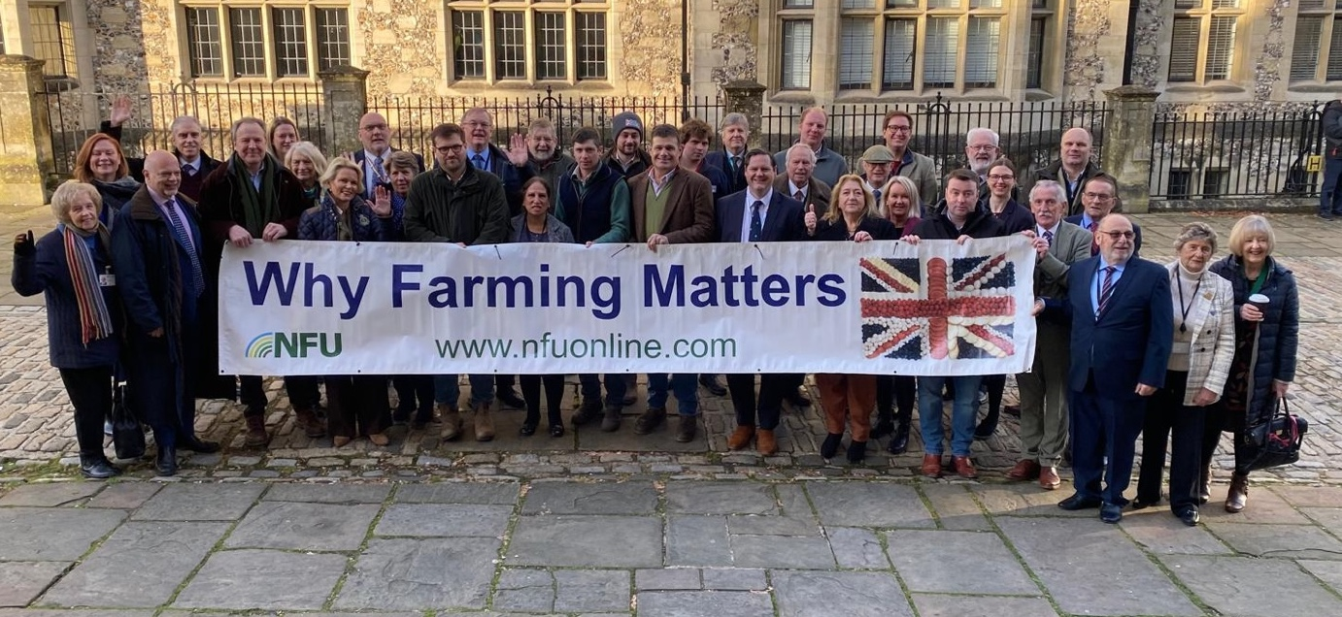
I will also be writing to the DEFRA secretary of state as a matter of urgency in support of farmers and the council would do all it can to support agriculture in the county.

Supporting Hampshire’s Businesses

I feel narcissism to be a common attribute for politicians. It certainly is for me. Which is why I was delighted when @@thebusinessmagazinegroup asked if they could interview me for the Southern Business Magazine.

Serious point though. It was a great opportunity to promote Hampshire and the Solent's businesses. Times are tough for business, even more so after the budget. The removal of Government support for local enterprise and economic development partnerships was really disappointing.

I am however incredibly proud to be Chair of the Hampshire Prosperity Partnership Board which brings together business and the local councils, (both the county and districts and boroughs); Hampshire has so much potential and, together with local businesses big and small we can still do much to support our local economy, encourage growth and create jobs.

That's why a devolution deal will be so important, it brings decision making closer to us, it enables Hampshire and the Solent to decide what's important to us and our business community and enact policies and attract investment to encourage that.

And yes, the really big picture feeds my narcissistic self.

You can read the interview here: https://lnkd.in/eR3j9X6W

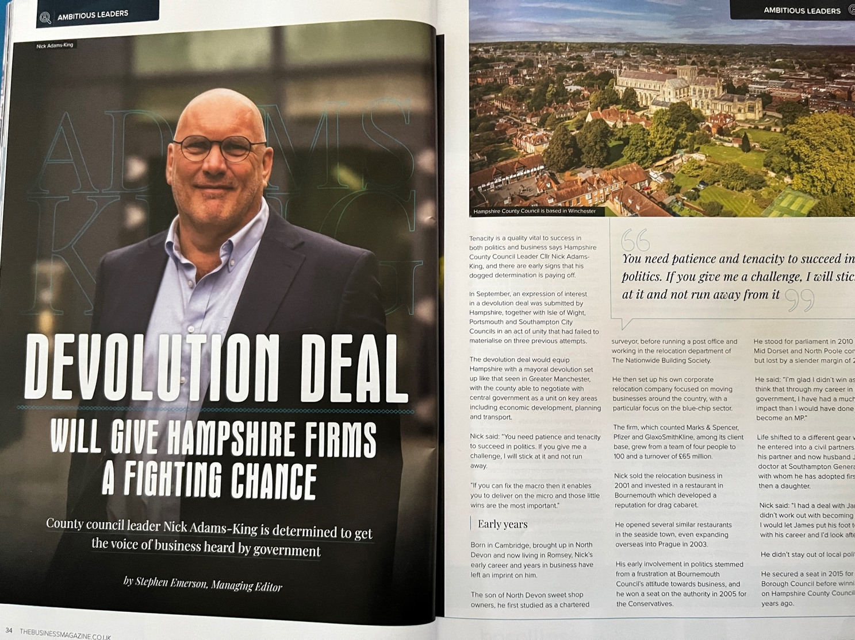

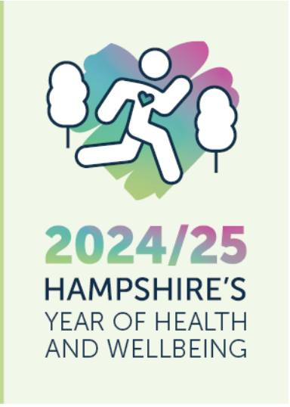
Hampshire 2050 Year of Health and Wellbeing

2024/25 is Hampshire 2050's year of Health and Wellbeing. Hampshire 2050 is the partnership which brings together the County Council with other local public sector bodies, community groups and charities.

Hampshire 2050 are highlighting case studies received from partners on action they are taking against the three priorities; updating you on relevant information in the health and wellbeing space; highlighting upcoming key national dates you can engage with on the three priorities and much more…

Case Studies

The Hampshire 2050 website (https://www.hants.gov.uk/.../havey.../visionforhampshire2050) has been updated and now houses a dedicated Year of Health and Wellbeing homepage.
Take a look at the new pages including up to date case studies submitted by partners on action across the three priorities.

National Health & Wellbeing

The Office for National Statistics (ONS) recently published their latest bulletin which explores quality of life and holistic progress across the UK, as well as updates on the UK Measures of National Well-being dashboard. (https://www.ons.gov.uk/.../ukmeasuresofnational.../dashboard)

Approximately 1 in 20 UK adults reported low satisfaction with their lives in April to June 2024.
Comparatively, for the Southeast the percentage of people reporting low levels of satisfaction is lower than all other regions.

Approximately 1 in 13 adults in Great Britain feels lonely often or always.
Here is some guidance around helping yourself or others feel more connected Loneliness - Every Mind Matters - NHS (https://www.nhs.uk/every.../lifes-challenges/loneliness/)

Healthy life expectancy at birth has decreased for both males and females in 2020 to 2022 compared with 2011 to 2013, when the time series began.

Newly released NHS figures show that obesity rates in children remain higher than at any other period on record. This article shows the breakdown for Hampshire districts ‘Obesity rates in children remain higher than pre-pandemic'.

Key Dates

December is UK Disability History Month, and December 3rd is the International Day of Persons with Disabilities.

Did you know that disabled people are more likely than non-disabled people to have mental health issues? This includes people with physical disabilities and developmental disabilities (Sense:https://www.sense.org.uk/.../adult-life.../mental-health/...).
70% of disabled people say that social isolation affects their mental health and wellbeing. (https://www.sense.org.uk/.../loneliness-rises.../)

Mental health problems also represent the largest single cause of disability in the UK (NHS England: https://www.england.nhs.uk/mental-health/adults/).

Free loan of stringed instruments by Hampshire County Council

Our Hampshire Music Service – which provides children and young people with the opportunity to learn to play a musical instrument – has been awarded a £600k Arts Council grant to buy new and specialist instruments for use in schools across Hampshire.

 This means we can now offer loans of more than 1,000 stringed instruments, including child-sized and full-sized violins, violas, cellos, and double basses.
If you are involved with a school or community group who would like to nurture the next generation of string players, you can now apply to access a selection of these instruments on free long-term loan.

You can find out more here: https://www.hants.gov.uk/News/20241119strings

HELP US TO MAKE IT EASIER TO WALK AND CYCLE IN HAMPSHIRE

Residents are being asked to help Hampshire County Council identify locations where physical barriers make it awkward and challenging to walk, cycle, wheel or scoot

Help us to make it easier to walk and cycle in Hampshire | Hampshire County Council

GRANTS AVAILABLE TO LOCAL ORGANISATIONS TO HELP HAMPSHIRE GO SMOKEFREE BY 2030

As part of Hampshire County Council’s drive to reduce the harm caused by smoking in local communities, a series of grants are to be awarded to the county’s district and borough councils, as well as to voluntary, community and social enterprise organisations to help quit smoking for good

Grants available to local organisations to help Hampshire go Smokefree by 2030 | Hampshire County Council

“AN INCREDIBLE DAY”: HAMPSHIRE CLIMATE CONFERENCE INSPIRES SCHOOL PUPILS TO PROTECT THE ENVIRONMENT

Hampshire’s Youth MPs are celebrating the resounding success of the latest Hampshire Climate Conference, which brought together over 200 enthusiastic pupils and teachers from 15 schools across the county this term

“An incredible day”: Hampshire climate conference inspires school pupils to protect the environment | Hampshire County Council

HAMPSHIRE’S AMBITION TO DOUBLE BUS USE

Making bus journeys on main routes faster, more frequent, reliable and greener, so that more people will want to travel by bus more often – instead of by car – is the ambition behind a Hampshire County Council and bus operators’ Plan, to at least double current bus use to 42 million journeys by 2038

Hampshire’s ambition to double bus use | Hampshire County Council

EMPOWERING LOCAL GOVERNMENT FOR THE FUTURE IS THE KEY TO TACKLING FINANCIAL PRESSURES

Hampshire County Council’s Leader, Cllr Nick Adams-King has warned that Government must fund local government properly or give Hampshire greater freedoms and flexibilities to help the Council tackle its financial pressures in the years ahead

Empowering local government for the future is the key to tackling financial pressures | Hampshire County Council

SETTING A COURSE FOR ECONOMIC SUCCESS IN HAMPSHIRE

Creating jobs that will bring employment security for Hampshire residents, serving the future needs of businesses across the county, and tackling financial and social inequality are among the priority outcomes to be driven by a strategy for economic prosperity in Hampshire

Setting a course for economic success in Hampshire | Hampshire County Council

HAMPSHIRE MUSIC SERVICE TO LOAN INSTRUMENTS FOR FREE TO ENCOURAGE THE NEXT GENERATION OF MUSICIANS

Young musicians across Hampshire are set to benefit from the loan of 1,000 used string instruments by Hampshire Music Service (HMS), the County Council’s music education provider and lead organisation for the Hampshire Music Education Hub

Hampshire Music Service to loan instruments for free to encourage the next generation of musicians | Hampshire County Council

WHITE RIBBON DAY AND 16 DAYS OF ACTIVISM AGAINST GENDER-BASED VIOLENCE

With the United Nations’ 16 Days of Activism against Gender-Based Violence starting with White Ribbon Day on Monday 25 November 2024, Hampshire County Council is reminding residents that help is available – whether you are experiencing abuse, worried about someone’s behaviour or welfare, or concerned about your own behaviour

White Ribbon Day and 16 days of activism against gender-based violence | Hampshire County Council

DECISION TO BE MADE ON FUTURE OF HAMPSHIRE COUNTY COUNCIL’S EDUCATION CATERING SERVICE

Hampshire County Council is to recommend sourcing school meals from other providers, rather than directly providing meals as it currently does via its in-house Education Catering service

Decision to be made on future of Hampshire County Council’s Education Catering service | Hampshire County Council

FURTHER COST OF LIVING SUPPORT FOR HAMPSHIRE HOUSEHOLDS

Struggling households in Hampshire are set to receive much-needed support as the County Council unveils plans to allocate £7.1 million in funding to help with rising food and energy costs

Further cost of living support for Hampshire households | Hampshire County Council

REAL-LIFE STORY INSPIRES HEARTWARMING SEARCH TO FIND MORE FOSTER CARERS IN HAMPSHIRE

Hampshire County Council is calling on more people to come forward and care for vulnerable children in need of loving homes this winter and beyond

Real-life story inspires heartwarming search to find more foster carers in Hampshire | Hampshire County Council

