Hampshire County Councillor report for Calleva Division – September 2024

Reporting Highway Problems

Links to report road issues are here:

Potholes: https://www.hants.gov.uk/transport/roadmaintenance/roadproblems/potholes

Tree/hedge problems:
https://www.hants.gov.uk/transport/roadmaintenance/roadproblems/treehedge

Flooding/drainage issues:
https://www.hants.gov.uk/transport/roadmaintenance/roadproblems/flooding

Pavement problems:
https://www.hants.gov.uk/transport/roadmaintenance/roadproblems/paving

Problems with rights of way:

https://www.hants.gov.uk/landplanningandenvironment/rightsofway/reportaproblem

When reporting an issue, you’ll be sent an email confirming a reference number for the report. If you would like me to follow this up for you then do please forward that message to me and I will chase for you

County Council Farms – Start Up Opportunities

County Farms - Hampshire County Council provide start up opportunities for young people hoping to make farming their career.

We’re not unique as a county in offering this, but have one of the most extensive county farm projects in the country, of which Hampshire is rightly proud.

There are new farming opportunities coming up, details of which are below. Do please share with anyone who might be interested.

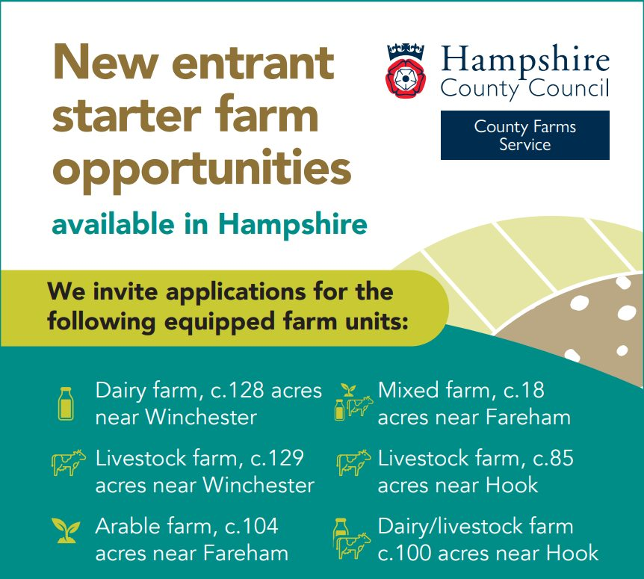

General HCC News:

COULD YOU SWAP YOUR CAR FOR A BIKE THIS SUMMER?

With longer daylight hours and warmer temperatures now is the perfect time to consider cycling. To help encourage people to get around on two wheels, the County Council has created a one-stop-shop website with everything you’ve ever wanted to know about cycling in Hampshire

Could you swap your car for a bike this summer? | Hampshire County Council (hants.gov.uk)

£1.5M BOOST FOR PEOPLE LED CLIMATE CHANGE ACTION

Lower energy bills could be enjoyed by more people in the future as more communities are given the ability to lead the charge on climate change through greener, more efficient energy initiatives that will reduce carbon emissions and, in turn, lower costs

£1.5m boost for people led climate change action | Hampshire County Council (hants.gov.uk)

EXAM HELPLINE NOW OPEN AS HAMPSHIRE’S POST-16 LEARNERS RECEIVE RESULTS

Thousands of Hampshire students have received the results of their hard work towards A-levels, T Levels, Technical, Vocational, and Apprenticeship qualifications

Exam helpline now open as Hampshire’s post-16 learners receive results | Hampshire County Council (hants.gov.uk)

TAP INTO SOLAR POWER TO SAVE ON BILLS AND TACKLE CLIMATE CHANGE

An opportunity for Hampshire residents to benefit from competitively priced, high-quality solar panel installation and save on future energy bills is once again available through the 2024 Solar Together scheme

Tap into solar power to save on bills and tackle climate change | Hampshire County Council (hants.gov.uk)

HAMPSHIRE OPENS GCSE HELPLINE AS THOUSANDS OF PUPILS SET TO RECEIVE RESULTS

Hampshire County Council is urging anyone with concerns about their GCSE or other Level 2 results to get in touch to talk through their post-16 options with a careers adviser

Hampshire opens GCSE helpline as thousands of pupils set to receive results | Hampshire County Council (hants.gov.uk)

MAKE ATTENDANCE TOP OF THE ‘BACK TO SCHOOL’ CHECKLIST FOR 2024/25

Hampshire County Council is renewing its call for parents and carers to prioritise regular school attendance in the new academic year

Make attendance top of the ‘back to school’ checklist for 2024/25 | Hampshire County Council (hants.gov.uk)

Cllr Rhydian Vaughan MBE

Fb.com/tellrhydian

